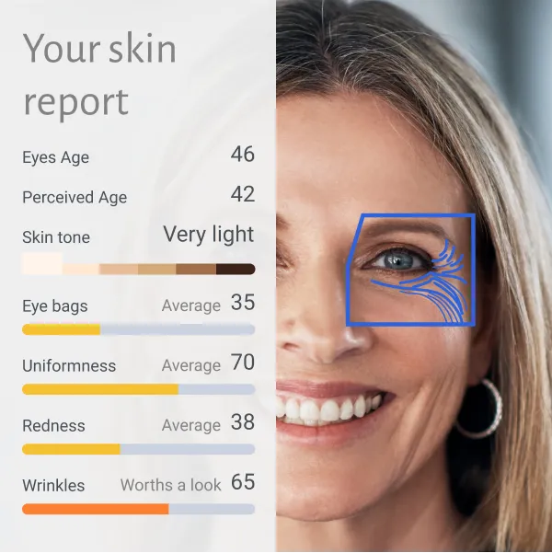

**Project Objective**

To develop an AI-driven system that analyzes facial features from an image, measures attributes such as eye age, skin tone, wrinkles, redness, and uniformity, and generates a detailed skin health report with grading (e.g., Poor, Average, Good).

## **Technologies**

1. **Programming Language**: Python
2. **Libraries/Frameworks**:
   * **Deep Learning**: TensorFlow or PyTorch
   * **Image Processing**: OpenCV
   * **Facial Analysis**: Dlib, MediaPipe, or DeepFace
   * **Skin Analysis**: SciPy and OpenCV for skin segmentation
3. **Pre-trained Models**:
   * Face Detection: MediaPipe Face Detection, Haar Cascades, or YOLOv8.
   * Wrinkle Detection: Pre-trained CNNs or Mask R-CNN for skin texture analysis.
   * Eye Analysis: Vision Transformers (ViT) or EfficientNet for detecting fine details like puffiness or age-related markers.
4. **Visualization Tools**:
   * Matplotlib or Seaborn for generating the skin health report.
   * Streamlit or Flask for building an interactive user interface.
5. **Data Labeling Tools**: LabelImg or Roboflow for custom dataset creation.

## **Steps to Implement**

### **1. Data Collection**

* **Sources**: Use publicly available skin health datasets or create your dataset by annotating features such as wrinkles, redness, skin tone, etc.
* **Attributes** to Collect:
  + Skin tone (light, medium, dark)
  + Wrinkle density
  + Redness level
  + Eye features (puffiness, dark circles)
  + Uniformity of skin texture

### **2. Preprocessing**

* **Face Detection**: Detect and segment the face using MediaPipe or Dlib.
* **Region of Interest (ROI) Extraction**:
  + Extract specific areas: eyes, cheeks, forehead, etc.
  + Use facial landmarks to focus on zones like the T-zone or under-eye area.
* **Data Augmentation**: Apply rotation, scaling, and flipping to improve model generalization.

### **3. Model Selection**

#### **Facial Feature Classification**

* **Skin Tone**: Histogram-based classifier or ResNet for classification.
* **Wrinkles and Fine Lines**: Mask R-CNN or a custom CNN to identify wrinkle patterns.
* **Eye Features (Puffiness, Dark Circles)**:
  + Vision Transformers (ViT) or EfficientNet for fine-grained detection.
* **Redness and Uniformity**:
  + U-Net or DeepLabV3 for segmentation to detect uneven patches or redness.

#### **Pre-trained Models for Transfer Learning**

* VGG16, ResNet, or MobileNet for transfer learning on custom skin health datasets.

### **4. Grading System**

Define grading criteria for each feature:

* **Skin Tone Uniformity**:
  + *Good*: Uniform skin tone with no visible discoloration.
  + *Average*: Slightly uneven tone.
  + *Poor*: Noticeable discoloration or patchiness.
* **Wrinkles**:
  + *Good*: Minimal wrinkle presence.
  + *Average*: Moderate fine lines.
  + *Poor*: Deep wrinkles and visible fine lines.
* **Redness**:
  + *Good*: No redness.
  + *Average*: Mild redness in specific areas.
  + *Poor*: Widespread redness.
* **Eye Features**:
  + *Good*: No dark circles or puffiness.
  + *Average*: Moderate puffiness or mild discoloration.
  + *Poor*: Severe puffiness or dark circles.

Use thresholds derived from data distribution or expert dermatology input.

### **5. Training and Evaluation**

* **Loss Function**: Use binary cross-entropy for binary classification (e.g., good vs. poor) and categorical cross-entropy for multi-class grading.
* **Evaluation Metrics**: Accuracy, F1-Score, Precision, Recall for classification models.

### **6. Report Generation**

Generate a skin health report with:

* Numerical scores for each feature.
* Grading (Good, Average, Poor) based on thresholds.
* Recommendations for improvement (e.g., "Use sunscreen to reduce redness").

### **7. Deployment**

* **Interactive Web Application**:
  + Use **Streamlit** for a user-friendly interface.
  + Users can upload an image, and the app will display the extracted features, grades, and recommendations.
* **Cloud Hosting**: Deploy the app using AWS, Azure, or Google Cloud.

## **Workflow**

1. Upload image → Preprocess (face detection, feature segmentation) → Apply models for feature extraction → Generate scores → Map scores to grades → Visualize the report.

## **Challenges and Solutions**

1. **Low-quality images**:
   * Use high-resolution datasets and noise reduction techniques.
2. **Data imbalance**:
   * Oversample minority classes or use weighted loss functions.
3. **Fine-grained feature detection**:
   * Use high-capacity models like Vision Transformers or ensemble models.

## **Expected Outcome**

* A system that generates a skin health report, categorizes features into grades (Poor, Average, Good), and provides actionable insights for improvement.

riven system that analyzes facial features from an image, measures attributes such as eye age, skin tone, wrinkles, redness, and uniformity, and generates a detailed skin health report with grading (e.g., Poor, Average, Good).

## **Technologies**

1. **Programming Language**: Python
2. **Libraries/Frameworks**:
   * **Deep Learning**: TensorFlow or PyTorch
   * **Image Processing**: OpenCV
   * **Facial Analysis**: Dlib, MediaPipe, or DeepFace
   * **Skin Analysis**: SciPy and OpenCV for skin segmentation
3. **Pre-trained Models**:
   * Face Detection: MediaPipe Face Detection, Haar Cascades, or YOLOv8.
   * Wrinkle Detection: Pre-trained CNNs or Mask R-CNN for skin texture analysis.
   * Eye Analysis: Vision Transformers (ViT) or EfficientNet for detecting fine details like puffiness or age-related markers.
4. **Visualization Tools**:
   * Matplotlib or Seaborn for generating the skin health report.
   * Streamlit or Flask for building an interactive user interface.
5. **Data Labeling Tools**: LabelImg or Roboflow for custom dataset creation.

## **Steps to Implement**

### **1. Data Collection**

* **Sources**: Use publicly available skin health datasets or create your dataset by annotating features such as wrinkles, redness, skin tone, etc.
* **Attributes** to Collect:
  + Skin tone (light, medium, dark)
  + Wrinkle density
  + Redness level
  + Eye features (puffiness, dark circles)
  + Uniformity of skin texture

### **2. Preprocessing**

* **Face Detection**: Detect and segment the face using MediaPipe or Dlib.
* **Region of Interest (ROI) Extraction**:
  + Extract specific areas: eyes, cheeks, forehead, etc.
  + Use facial landmarks to focus on zones like the T-zone or under-eye area.
* **Data Augmentation**: Apply rotation, scaling, and flipping to improve model generalization.

### **3. Model Selection**

#### **Facial Feature Classification**

* **Skin Tone**: Histogram-based classifier or ResNet for classification.
* **Wrinkles and Fine Lines**: Mask R-CNN or a custom CNN to identify wrinkle patterns.
* **Eye Features (Puffiness, Dark Circles)**:
  + Vision Transformers (ViT) or EfficientNet for fine-grained detection.
* **Redness and Uniformity**:
  + U-Net or DeepLabV3 for segmentation to detect uneven patches or redness.

#### **Pre-trained Models for Transfer Learning**

* VGG16, ResNet, or MobileNet for transfer learning on custom skin health datasets.

### **4. Grading System**

Define grading criteria for each feature:

* **Skin Tone Uniformity**:
  + *Good*: Uniform skin tone with no visible discoloration.
  + *Average*: Slightly uneven tone.
  + *Poor*: Noticeable discoloration or patchiness.
* **Wrinkles**:
  + *Good*: Minimal wrinkle presence.
  + *Average*: Moderate fine lines.
  + *Poor*: Deep wrinkles and visible fine lines.
* **Redness**:
  + *Good*: No redness.
  + *Average*: Mild redness in specific areas.
  + *Poor*: Widespread redness.
* **Eye Features**:
  + *Good*: No dark circles or puffiness.
  + *Average*: Moderate puffiness or mild discoloration.
  + *Poor*: Severe puffiness or dark circles.

Use thresholds derived from data distribution or expert dermatology input.

### **5. Training and Evaluation**

* **Loss Function**: Use binary cross-entropy for binary classification (e.g., good vs. poor) and categorical cross-entropy for multi-class grading.
* **Evaluation Metrics**: Accuracy, F1-Score, Precision, Recall for classification models.

### **6. Report Generation**

Generate a skin health report with:

* Numerical scores for each feature.
* Grading (Good, Average, Poor) based on thresholds.
* Recommendations for improvement (e.g., "Use sunscreen to reduce redness").

### **7. Deployment**

* **Interactive Web Application**:
  + Use **Streamlit** for a user-friendly interface.
  + Users can upload an image, and the app will display the extracted features, grades, and recommendations.
* **Cloud Hosting**: Deploy the app using AWS, Azure, or Google Cloud.

## **Workflow**

1. Upload image → Preprocess (face detection, feature segmentation) → Apply models for feature extraction → Generate scores → Map scores to grades → Visualize the report.

## **Challenges and Solutions**

1. **Low-quality images**:
   * Use high-resolution datasets and noise reduction techniques.
2. **Data imbalance**:
   * Oversample minority classes or use weighted loss functions.
3. **Fine-grained feature detection**:
   * Use high-capacity models like Vision Transformers or ensemble models.

## **Expected Outcome**

* A system that generates a skin health report, categorizes features into grades (Poor, Average, Good), and provides actionable insights for improvement.